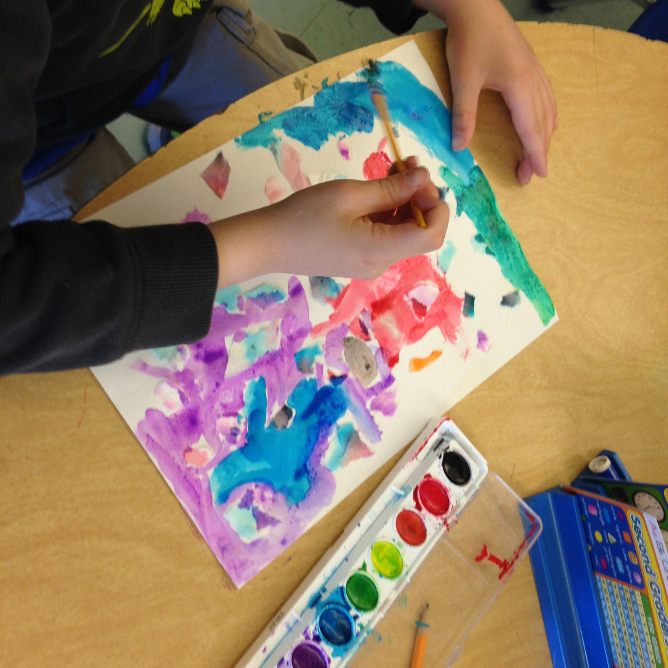

August (TBD)

Hello! My name is Cindy Steeves and I will be your child’s second-grade teacher. It’s so exciting to have the chance to meet the students on step-up day. This allows me to learn a bit about their interests, families, favorite books, stories, hobbies, and more. I’ve worked at HES for quite a while. After years of teaching French, Spanish, and math, this will be my eighth year as a 2nd-grade teacher. In 2012 I earned my master’s degree from Lesley University and have continued post-graduate work ever since. I live here in Harvard with my husband, Bill, and have four wonderful, adult children: Peter, Jenny, Sarah, and Jackie (all of whom attended HES).

Wishing you and your family a fantastic summer!

On step-up day the first-graders visit my classroom to enjoy a “sneak peek” of the coming attractions for next year. They discover the highlights and favorite memories written by previous years’ second-graders. While many children love our science units (Earth Materials, Engineering, Matter, and Ecosystems), others write about our virtual fields trips and Skype events shared with far away students. Still other kids point to the exciting new book series they found, and classic fairy tales. Most will long remember our big June poetry/music show.

Welcome!

Families are welcome to meet teachers at the HES playground!

# Fun Learning

Caregivers visit HES to learn about their child’s curriculum.

September (TBD)

##### Curriculum Night at HES

August 31st, 2022

##### First Day of School!

##### Popsicle Party/

##### Meet & Greet

#### Late Summer School Events:

# Your Child’s 2nd Grade Teacher

**Second Grade is Spectacular**

Bring your lunch, water, school supplies, & smile.

Summer 2022